The gun bird

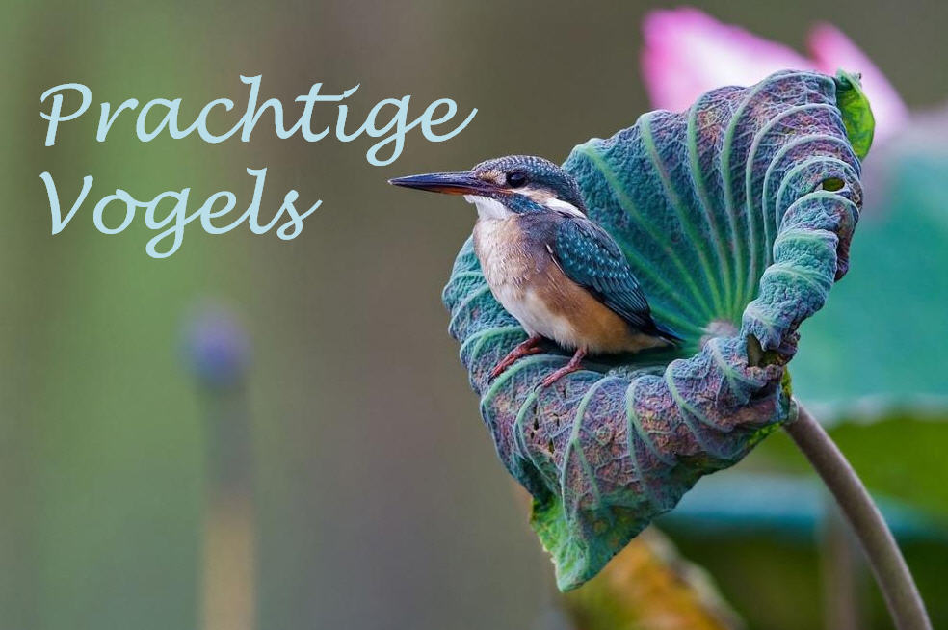This is the aggressive bird named gun bird, because it always carries a gun around. If you come to close to the bird it feels threatened, because it is protecting his eggs. So if you come to close to its nest it will kill you with its gun. That is why it named gun bird. It is very aggressive because it wants to protect his eggs.

The bird eats worms, berries, seeds and nuts. Even though he looks small, round and cute, you should be careful, because he can grab his gun in one second. It lives in the amazon forest. The gun bird is also called ‘the protector of the forest’, because it shoots the people who want to cut the trees. ‘How do these birds have guns?’ you might ask. Here’s your answer: They make the guns with the newest birds technology.

